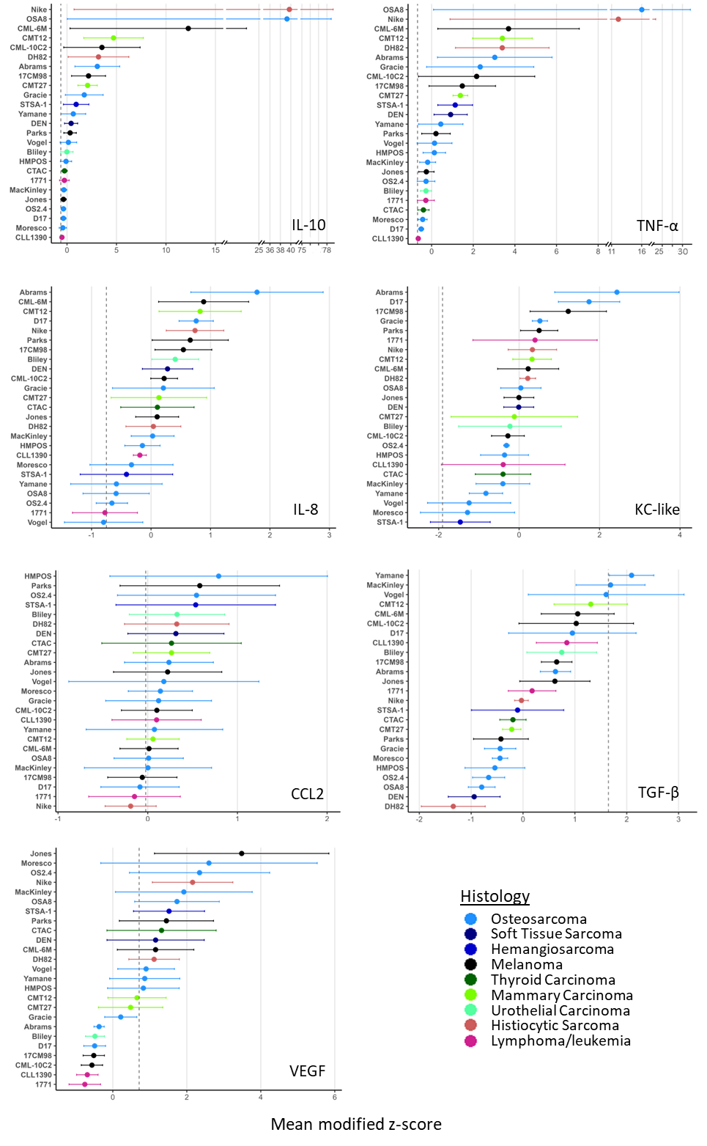
Figure 1: Modified z-scores of each analyte. Mean modified z-score for each cytokine secreted by donor macrophages, ranked in descending order, color-coded by histology. Vertical dotted line represents the modified z-score of control macrophages from the same 3 donors. Data are mean +/- SEM; n=3.
Table 1. Analytes included for further analysis. Data are expressed as modified z-scores. A modified z-score of +1.0 indicates the measurement lies one median absolute deviation (MAD) above the median, -1.0 indicates one MAD below. Interclass correlation coefficients (ICCs) represent the fraction of total variance attributable to donor identity and the corresponding p-value from a likelihood-ratio test comparing models with and without donor as a random effect. Min = minimum, Max = maximum.
Analyte | Median | Min | Max | Range | ICC | p-value
VEGF | 0.8998 | -0.7566 | 3.4840 | 4.2410 | 0.614 | <0.001
TNF-α | 0.4402 | -0.6415 | 16.020 | 16.660 | 0.182 | 0.002
IL-10 | 0.4153 | -0.5104 | 39.730 | 40.240 | 0.115 | 0.028
TGF-β | 0.1755 | -1.3450 | 2.0940 | 3.4380 | 0.020 | 0.604
CCL2 | 0.1410 | -0.1905 | 0.7910 | 0.9815 | 0.754 | <0.001
IL-8 | 0.1068 | -0.7979 | 1.7820 | 2.5800 | 0.209 | <0.001
KC-like | -0.0092 | -1.4630 | 2.4330 | 3.8950 | 0.096 | 0.055

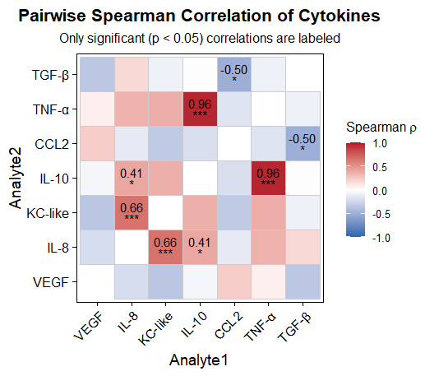
Figure 2: Spearman correlation heatmap of cytokine secretion. Each tile is colored by the Spearman ρ value (red = positive correlation, blue = negative correlation; scale bar at right). Only correlations that reached statistical significance (two‐tailed Spearman test, p < 0.05) are annotated.

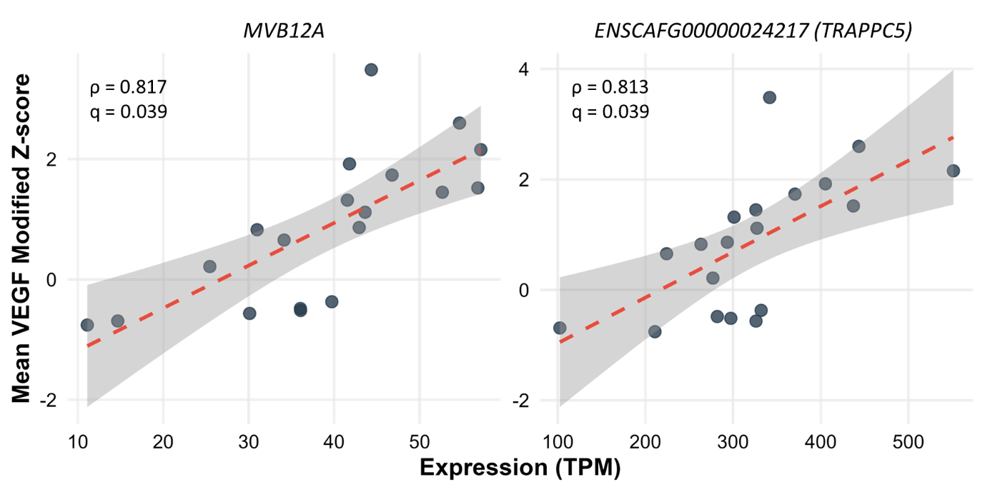
Figure 3: Spearman correlation between gene expression and VEGF response. Scatter‐plots showing the relationship between TPM‐normalized RNA-seq expression of MVB12A (left panel) and TRAPPC5 (ENSCAFG00000024217; right panel) versus mean VEGF modified Z-scores. Dashed red lines depict the linear regression trend with 95% confidence bands; annotations show each gene’s Spearman ρ and q-value.

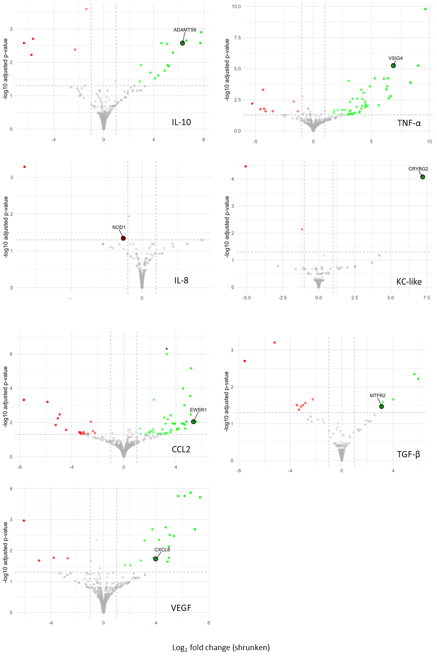
Figure 4: Volcano plots of DEGs in pairwise analysis. In each panel, the x-axis shows the shrunken log₂ fold-change and the y-axis shows –log₁₀ of the Benjamini–Hochberg–adjusted p-value. Dashed vertical lines at ±1 log₂FC and a dashed horizontal line at FDR = 0.05 indicate the significance thresholds. Genes with |shrunken log₂FC| ≥ 1 and FDR ≤ 0.05 are colored green (up-regulated) or red (down-regulated); all others are shown in gray. Asterisks mark values that exceed the plotted range (e.g. the CCL2 outlier is capped for display). Some genes of interest are highlighted in associated Table 3 (log2FC = log2FoldChange, padj = adjusted p-value).

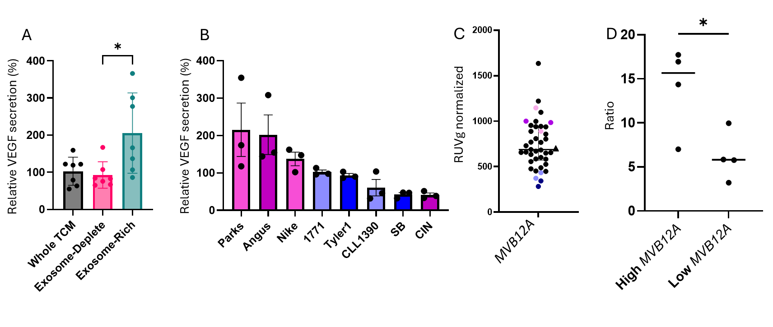
Figure 5: Validation of MVB12A’s role in exosome-associated VEGF stimulation. (A) VEGF secretion by macrophages (% of control) after treatment with unmodified tumor-conditioned media (TCM), exosome-deplete TCM, and exosome-rich media, n=3. (B) VEGF secretion (% of control) from TCM derived from high- versus low-MVB12A cell lines, n=3. (C) RUVg-normalized counts MVB12A expression across all cell lines. For (B) and (C), colors indicate “high” (purple) and “low” (blue) expressors; darker shades denote the discovery set, lighter shades the validation set. (D) Ratio of presumed exosome-associated to free VEGF in the 7 high- vs. low-MVB12A lines from (A) and (B) (p = 0.032 on a Student t-test).

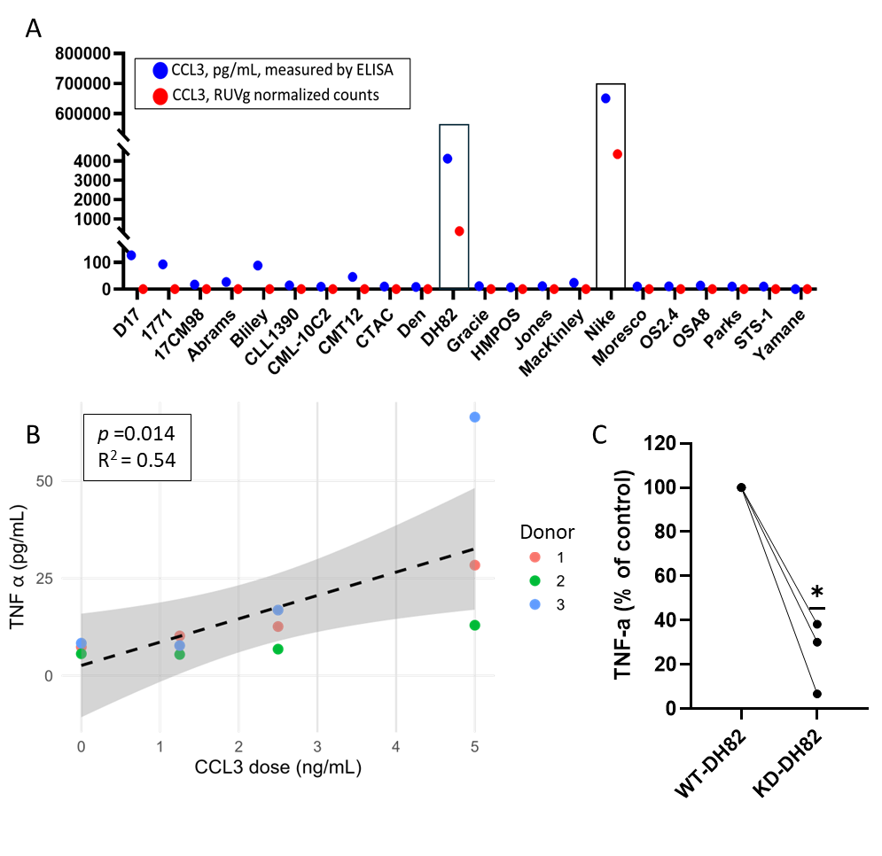
Figure 6: CCL3‐induced TNF-α secretion by macrophages. (A) CCL3 protein (blue) and mRNA (red) levels in tumor-conditioned media from multiple cell lines. DH82 and Nike exhibit the highest transcript and secreted protein, whereas some lines show low protein despite undetectable mRNA. (B) Dose-dependent TNF-α secretion by primary macrophages in response to recombinant CCL3 (0–5 ng/mL), modeled using a donor-nested mixed‐effects regression, n=3. (C) Knockdown of CCL3 in DH82 cells (KD-DH82) prior to TCM collection markedly reduces macrophage TNF-α secretion across three independent donors compared to TCM collected from wildtype (WT)-DH82, n=3.

